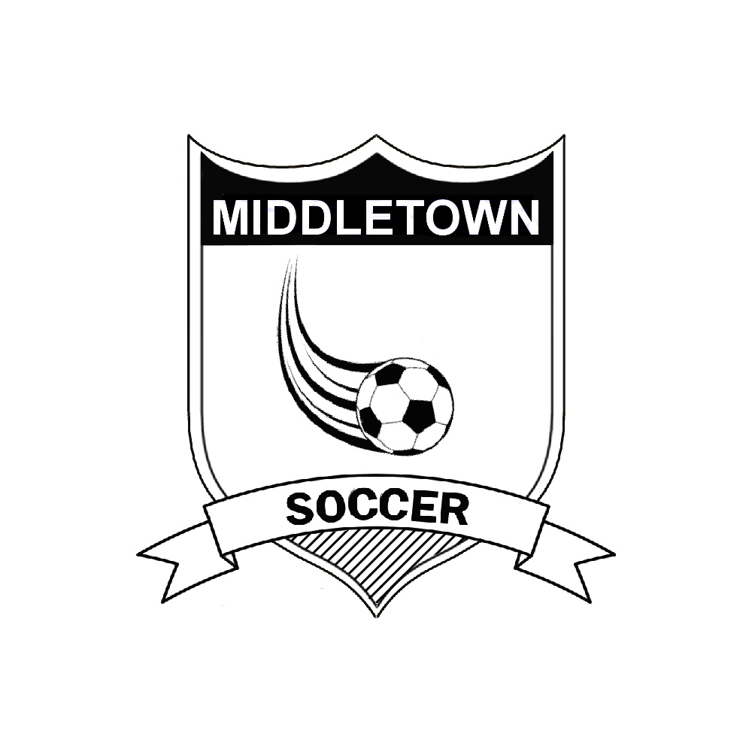
Dear Middletown Business Owner,
The Middletown Youth Soccer Association is seeking Sponsors for our fall MYSA soccer season. Your business is valuable to the Middletown community and we are offering advertising of your company name through your paid sponsorship of $200. With your paid sponsorship, thousands of individuals will see your company name week after week during our soccer season. We also offer advertising on our soccer website which hundreds will visit weekly. Your sponsorship also assists those less fortunate to play soccer if they are financially unable. We want any child who wants to play soccer, to be able to play! We will assist any child who wants to play soccer.
Our sponsorship fee of $200, is tax deductible. We are hoping that with the lowering of our sponsorship fees, we can entice company leaders such as you, to sponsor a team for our youth in the Middletown Youth Soccer Association.
This year we will not be able to return the sponsorship fee to you or the company after July 1st.
As a Sponsor, we offer the following sponsorship options to you and your business and they are:
(1) Having your company name on the MYSA website (with approval)
(2) Having a child on a specific aged team (candy, pass, wings, striker, kickers)
(3) Having another adult as a coach or assistant coach and have their child on your company sponsored team.
Please consider making a sponsorship and mail your paid sponsorship fee to the P.O. Box below.
We thank you for your community support and for consideration your sponsorship to the Middletown Youth Soccer Association this year!
“Many children would not be able to play soccer without the generous support of our sponsors!”– MYSA Soccer

Middletown Youth Soccer Association Sponsorship Form
(PLEASE PRINT IN BLACKOR BLUE INK)
Company / Organization: ________________________________________________________
Address: _____________________________________________________________________
City, State, Zip: ________________________________________________________________
Contact Mr./Mrs./Ms.: __________________________________________________________
Phone (______) ______-______ Fax (_____) ______-_______
Contact Email: ________________________________________________________________
Please attach a letterhead or business card with company logo that will go on the front of the uniform
(You can email the logo to MiddletownYouthSoccerOhio@gmail.com)
Please check your selection box option:
□ I will sponsor a team selected by MYSA.
□ I will sponsor a specific team (age specific group). As a sponsor, you may choose a child to be on your sponsored team OR you may request a coach and their child to on your Company Sponsored team.
□ Child (ren) Name: _______________________________________________ DOB: _____ Age: _____ Boy or Girl
□ Coach Name: __________________________________________________
Please check one of the selection boxes options:
□ Print our name in a block lettering (no logo attached).
□ Print sponsor company logo using the enclosed
□ Print our sponsored company name using the logo from previous seasons(s).
Questions contact MYSA Board at middletownyouthsoccerohio@gmail.com
Send this form along with your check by July 1st to:
MYSA, ATTN: Sponsorship, P. O. Box 1199, Middletown, OH 45042
X _______________________________________________ Date: ______/______/______
By signing above, Company Representative Approves use of company sponsored link on the MYSA website for the fall season. (Send link to your company to our email address.)
MYSA Use Only Check #_____________ Received By: _____________________________________________
Sponsored Team Name: ________________________________________
Logo: Y / N Age Group (Please Circle One): Candy Passer Wings Kicker Boy or Girl Team_________

